Section 1: Getting Started; Software Basics

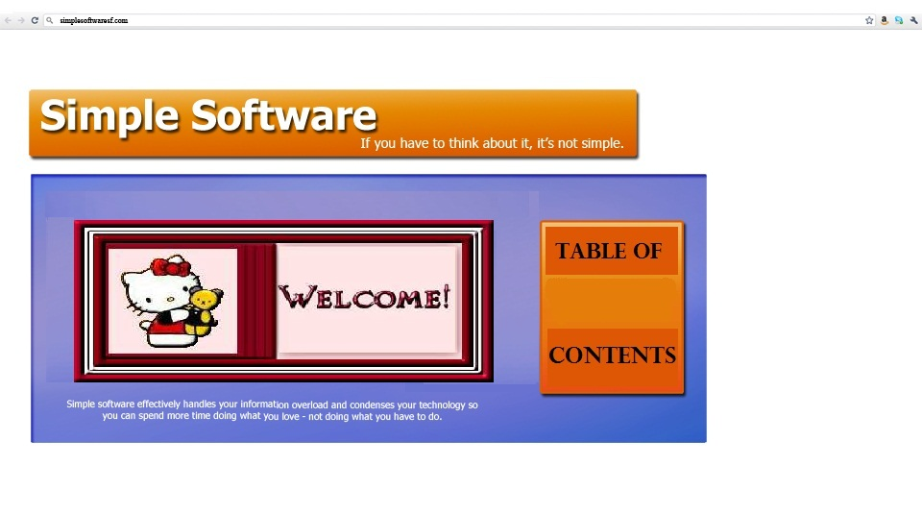

In this section you will learn the basic fundamentals of moving around in your workspace*.*

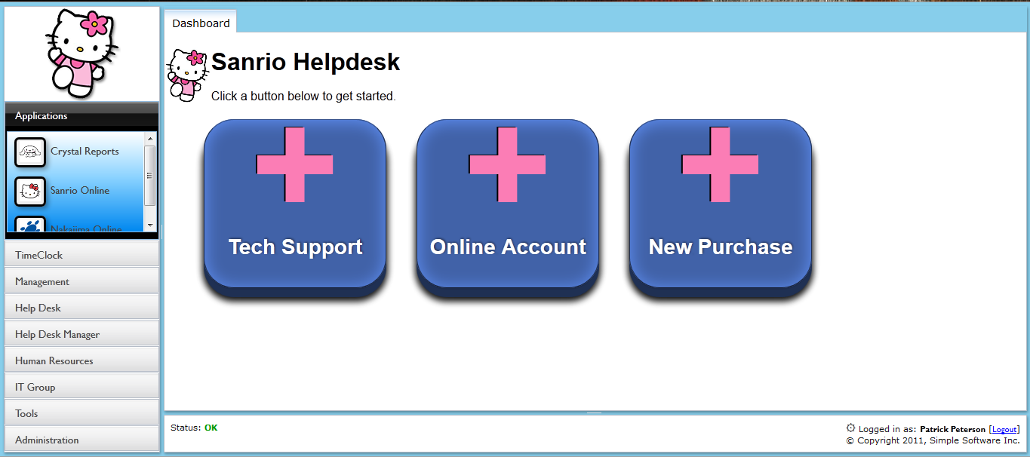

Lesson 1: “Workspace basics or (101)”

Accessing your Sanrio Workspace

Since your Sanrio Workspace resides online, you will access our software using most internet ready computer or mobile device. We suggest you download Firefox 5.0+ in order to enjoy the full experience.

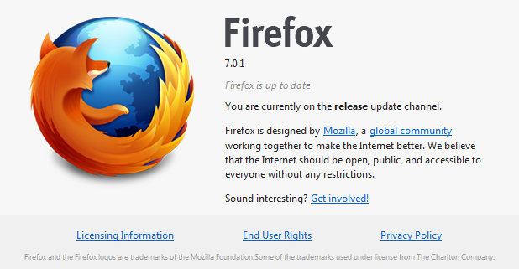

If your company does not have a workspace, you may create one from our homepage at:

<http://www.simpsf.com>

Simply click on ‘Free Trial’, complete the form, and an email will be sent with your new workspace internet address. We suggest you bookmark it!

Open your Internet browser and type your workspace address into the address bar.

<http://sanrio.simpsf.com>

Logging On

If you entered the correct address, you will see a login screen like this:

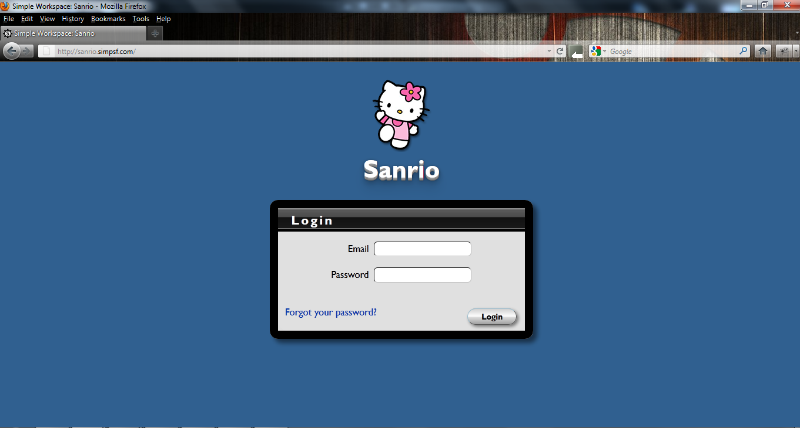

(There is a “Forgot your password?” link which will guide you through the necessary steps to retrieve your password.)

Login using your email address and password. For employees without an email address, login using your first initial + last name (John Doe would login as jdoe). Default passwords for Sanrio is your employee number located on your check stub.

Lesson 2: “Navigating your Workspace”

After logging in, you will see your company’s Simple Software Workspace.

The “Sanrio Helpdesk” dashboard contains shortcuts to various requests. Within the Helpdesk you can request:

* Tech Support
* Online Account
* New Purchase



Let’s take a moment to discuss the application “Workspace” layout…

Application Layout (Your working parts!)

There are many parts that make up your Workspace. Our goal is to design a flexible interface that looks familiar to anyone that has used email.

We will go over these in detail but here is a quick reference:

1. Your Logo
2. Modules
3. Processes
4. Work Area
5. Tabs
6. Status Bar
7. Change your password
8. Logout

##### 

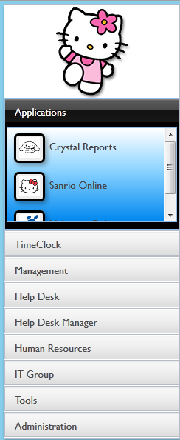

Sometimes referred to as “left navigation pane”

##### Your Logo



There are many ways of customizing your Workspace, and having your logo displayed is just one of them. Simply upload a new logo called logo.png and everyone that uses your Workspace will automatically see it!

##### Modules:

##### 

Think of Modules as folders that group your applications. This is a helpful way of keeping similar tasks together as well as granting access to your apps. Below your “Hello kitty” logo is a list of modules which can include;

* Applications
* Time Clock
* Management
* Help Desk
* Help Desk Manager
* Human Resources
* IT Group
* Tools
* Administration
* Help

##### Processes:



Processes are the applications that will help run your business. Under each module there are different buttons (processes) that pertain to that specific module. Only modules and processes you have been granted access to will appear in your workspace.

They can consist of:

* applications like Time Clock, Calendars, To Do List, CDR Mail, etc.;
* existing web applications;
* custom Tables;

You will also find Simple’s tools to manage and customize your application, or grant user access.

##### Work Area:

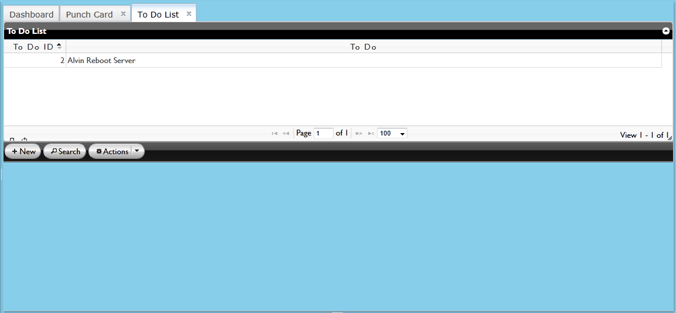

The work area of the application is where active processes will be running. You may identify the active process of your choice in order to get specific information by looking at the grid.

1. **Tabs**



If you select the process titled “To Do List”, a tab will open in your workspace. On the right there will be two tabs open. The first tab will read “Dashboard”; Next to it you will see any other processes you have opened. The “To Do List” tab will be bold because it is the active process.

Tabs give you quick access to switch tasks without losing any data.

The page is never reloaded!

You can switch back and forth just like a desktop application.

###### Multi-tasking online through Simple Software gives you an edge that most online applications can’t provide.

1. **Status Bar:**



The status bar provides information such as:

* system status
* add, delete, update, relate to records
* person that is currently logged in

It also allows you to change your password. We suggest you change your password now…

1. **Change Password:**



Locate the ‘gear’ symbol and click on it in order to change your password.

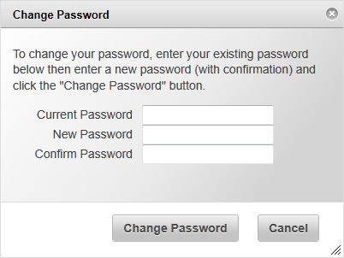

All passwords are database encrypted so they cannot be retrieved!

1. **Log Out:**



After you change your password, log out and then log back in.